Recuva/CCleaner Assignment
What I did
Downloaded and installed Recuva (Free).
I went to ccleaner.com/recuva and installed the free version. During setup I left default options on.
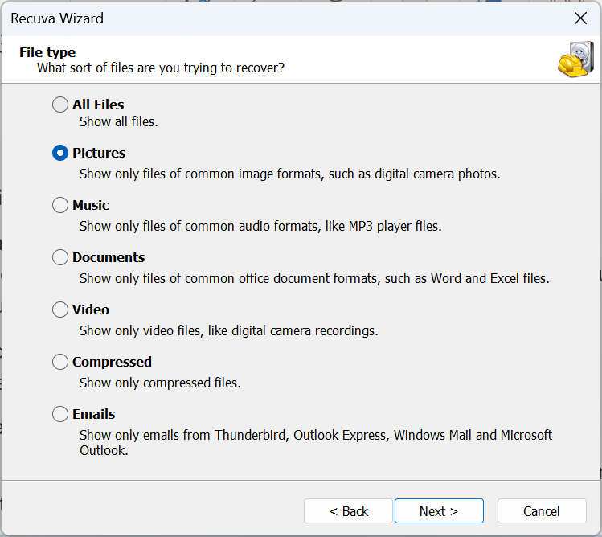
Prepared the sample file.
I downloaded Dilbert_Security.gif and verified it opened normally.
Soft delete and restore test (Recycle Bin).
I deleted Dilbert_Security.gif to the Recycle Bin. I opened the Recycle Bin, restored the file, and confirmed it still opened correctly.
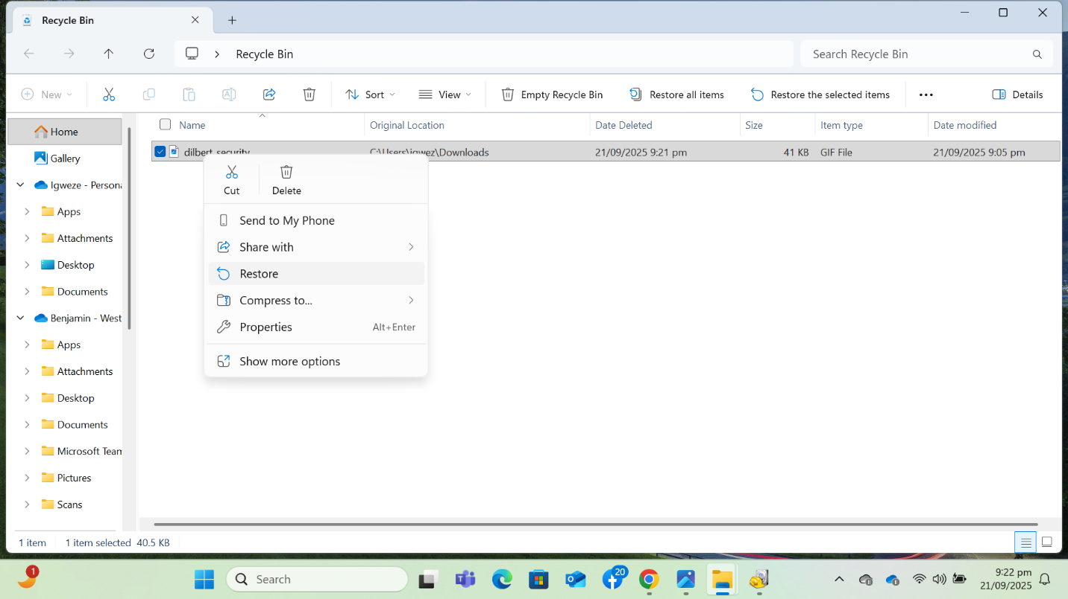
Permanent delete test (empty Recycle Bin).
I deleted the file again. I opened the Recycle Bin and permanently deleted it by emptying the bin.
Installed CCleaner Professional trial.
I went to ccleaner.com/download and installed the Professional trial.
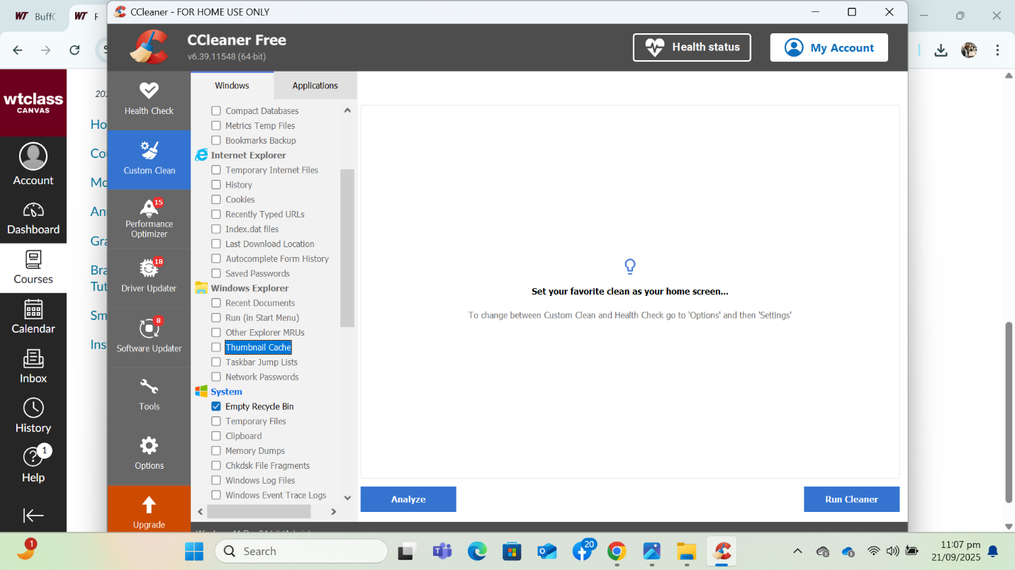
Secure deletion with CCleaner.
I deleted it normally first so it went to the Recycle Bin. In CCleaner, I ran Custom Clean and selected empty recycle bin
Attempted recovery again with Recuva (after secure wipe).
I re-ran Recuva’s Deep Scan for GIFs to see whether Dilbert_Security.gif could still be found and/or restored.

What were the results?
- After “permanent delete” (emptying the Recycle Bin):
Recuva couldn’t find Dilbert_Security.gif as a deleted item. I tried to find the file but it wasn’t available.
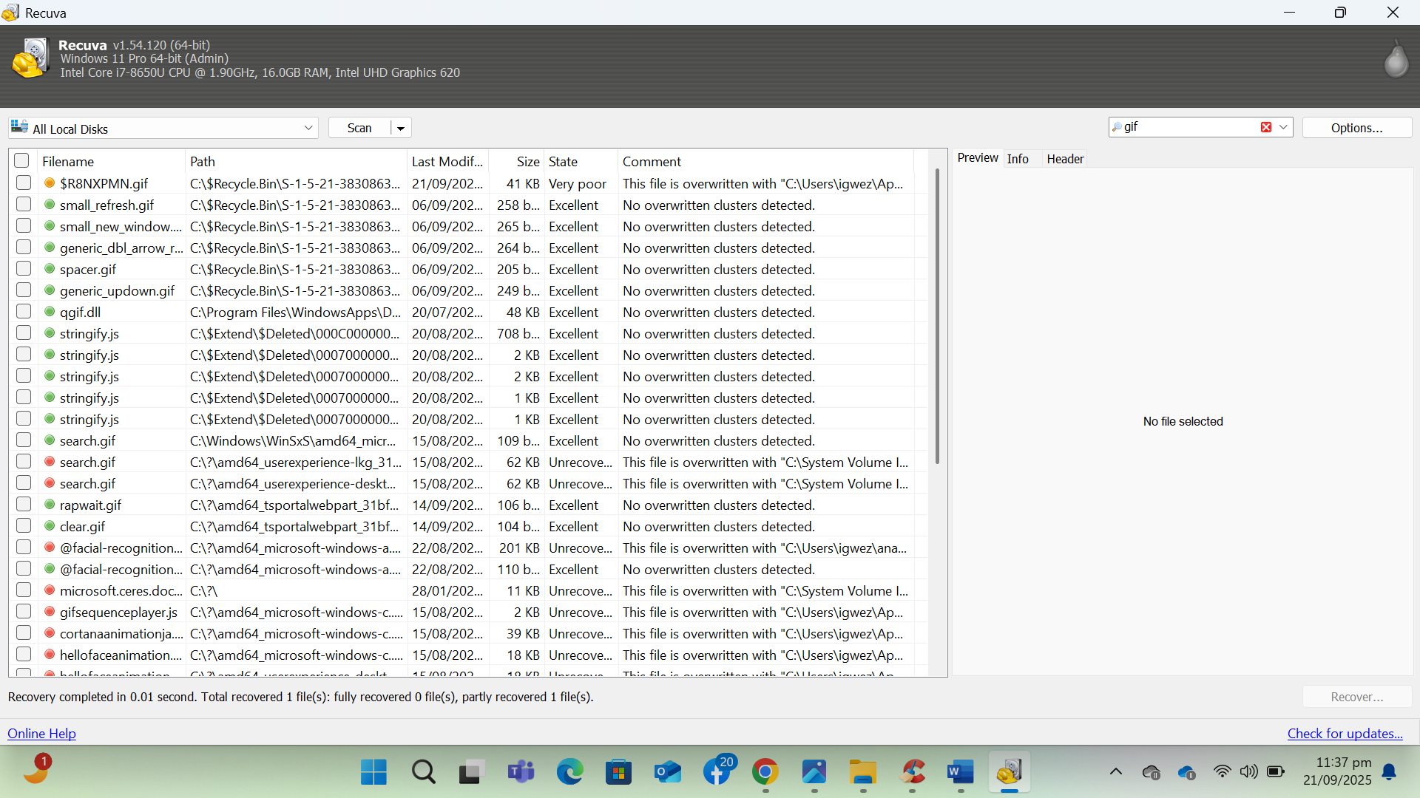
- After CCleaner’s secure cleaning/wipe:
On the second pass with Recuva, Dilbert_Security.gif showed as unrecoverable/corrupted. I could not open a valid image, or Recuva simply didn’t list it.
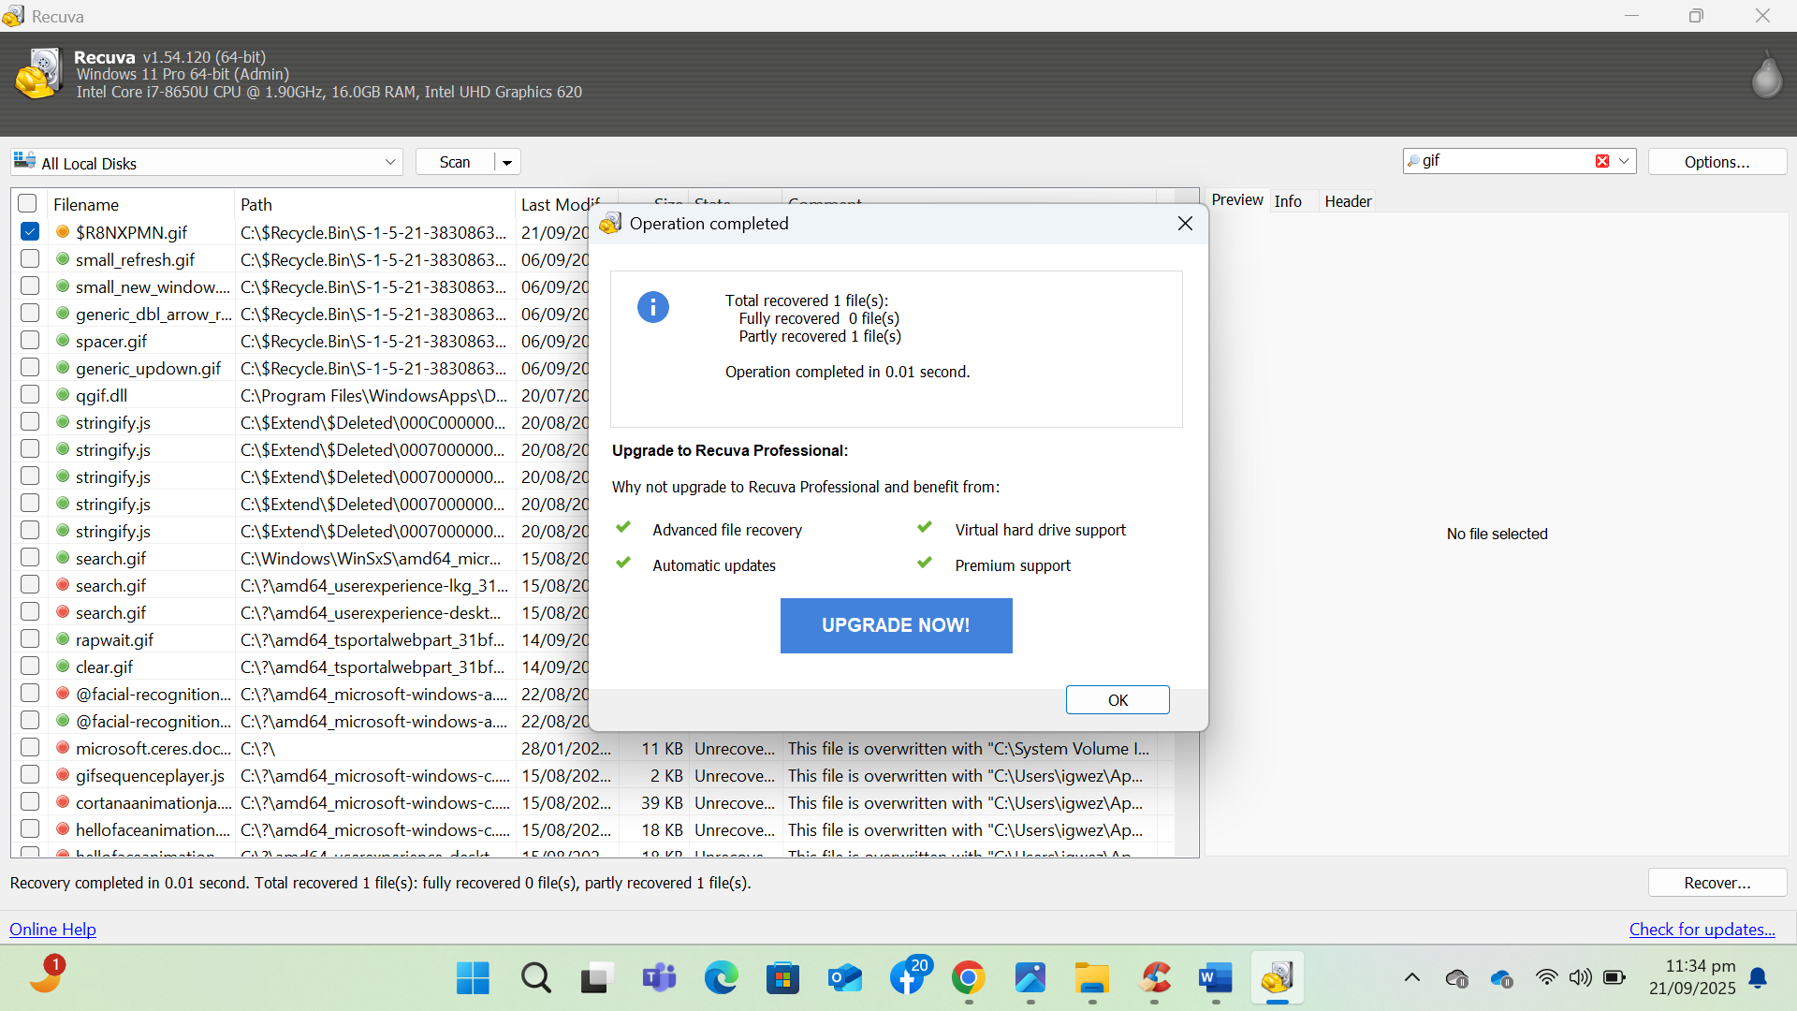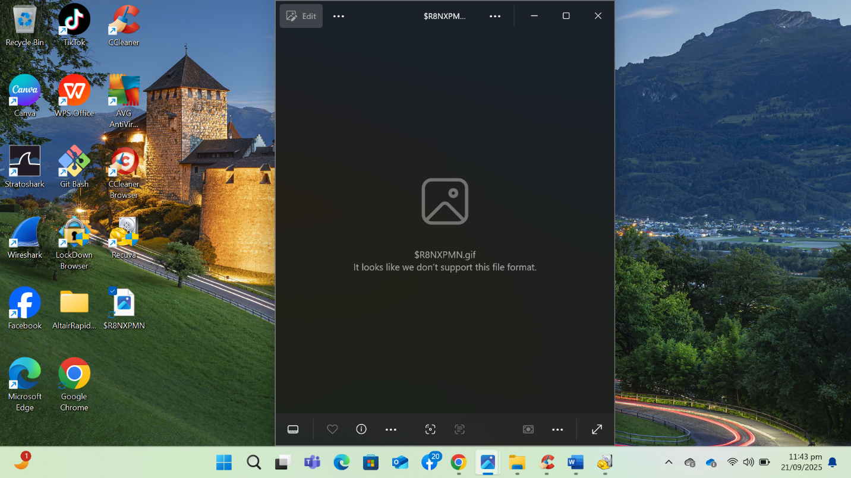
  - What this means: CCleaner’s cleaning (Recycle Bin + Wipe Free Space) overwrote previously freed clusters, destroying the recoverable data remnants that Recuva relied on.

What I learned (key concepts & takeaways)
- How files are stored on a drive (NTFS overview):
On Windows (NTFS), the system tracks files in a table (the MFT). The file’s directory entry and MFT record point to clusters (physical disk locations) where the data lives.
- What “delete” actually does:
  - Soft delete (Recycle Bin): Windows just moves the file into a hidden Recycle Bin folder and changes its name/metadata. The bytes remain untouched.
  - Emptying the Recycle Bin / “permanent” delete: Windows removes the directory/MFT references and marks those clusters as free. The data bytes usually remain until something overwrites that space. That’s why “permanently deleted” files are often recoverable.
- How Recuva recovers files:
Recuva scans the MFT for records marked as deleted and tries to map the original clusters. If the metadata is gone or incomplete, it can do a deep scan and file carving by searching for known file signatures (e.g., GIF starts with GIF87a/GIF89a). Recovery succeeds if those clusters haven’t been overwritten and enough of the file’s structure is intact.
- How CCleaner permanently deletes files:
CCleaner can (a) empty the Recycle Bin and (b) overwrite free space on the drive with patterns (e.g., single-pass zeros or multi-pass methods). Overwriting those clusters destroys the leftover data, so tools like Recuva no longer have anything meaningful to reconstruct.
  - On SSDs, secure deletion is trickier. TRIM plus the controller’s wear-leveling means once blocks are trimmed, recovery is typically not feasible—but multi-pass overwrites aren’t recommended for SSD health. A one-pass wipe of free space or using the drive’s built-in secure erase is generally preferred.
- Practical takeaways:
  - “Delete” ≠ “erase.” Until overwritten, data often remains recoverable.
  - To truly remove sensitive files, use secure deletion (Recycle Bin clean + Wipe Free Space) or encrypt the drive so future deletes occur on encrypted data.
  - Recovery results depend on timing, system activity, storage type (HDD vs SSD), TRIM, and whether free space has been wiped.
conclusion
This exercise showed how easy recovery can be after a normal delete, and how effective a secure clean/wipe is at preventing recovery. In practice, combine encryption + secure deletion for strong data hygiene, and remember that SSDs behave differently because of TRIM and wear-leveling.

